1. INTRODUCTION & OBJECTIVES
Database Interface is an industry-standard tool for application development. Using Database Interface, developers can interact with any back end software (i.e. Oracle, MS-SQL Server, MS-Access, My-SQL etc). The database interface can be used to build, test, and debug PL/SQL packages, procedures, triggers, and functions. Database Interface users can create and edit database objects such as tables, views, indexes, constraints, and users. Database Interface's SQL Editor provides an easy and efficient way to write and test scripts and queries, and its powerful data grids provide an easy way to view and edit data related to any DBMS/RDBMS tool.
The requirements of a database application developer will vary from project to project. On a large team where DBAs manage the DDL, a developer may spend 90% of development time coding and testing SELECT queries to issue from 3GL or 4GL application code. In such an environment, a developer might be concerned only with viewing the DDL and database code. On smaller teams, a developer might be responsible for maintenance of the development schema, movement of test data between schemas, writing procedure code, populating tables from legacy sources, and more. Database Interface facilitates all of these needs.
For example if you are working with oracle, you don't have to be a PL/SQL expert to access database objects with Database Interface. You can view the Oracle Dictionary, tables, indexes, stored procedures, and more - all through a multi-tabbed browser. Database Interface utilizes direct Oracle OCI calls for full access to the Oracle API.
Advanced editing features save time and increase productivity. Code can be created from shortcuts and code templates. You can even create your own code templates.

Use Database Interface to
- Create, browse, or alter objects (tables, views, indexes, etc.) including Oracle8 TYPE objects
- Graphically build, execute, and tune queries
- Edit and Debug PL/SQL and profile "stored procedures" including functions, packages, and triggers
- Search for objects
- Find and fix database problems with constraints, triggers, extents, indexes, and grants

Project Advantages:
- Flexibility. The end-user should be able to use any major commercial (or open-source) database on the market. Moreover, the end-user should be able to customize the look-and-feel of the front-end; this includes the ability to internationalize the application.
- Maintenance. Both external documentation (like this) and inline java docs should explain how things work. I've tried to write clean Java code so that developers who build on database interface will have a clear, easily extensible starting point.
- Ease of Use. Installation is simple; you just have to create a .war file and drop it in the right directory/folder. The Java search engine interface is text-based, and intended to provide easy access to search operations.
IDENTIFICATION OF NEED
To clearly identify the need of this application, I will try to exemplify one situation.
A project manager is dealing with an enterprise application, which is in the development phase. This application has got different faces such as a desktop interface, a web interface and mobile interface. Initially all these applications are not integrated. Once these entire interfaces are working well, they are going to be integrated. In such occasion the database which is being used must be same. But while designing these individual modules, creating a sample database for each module and perform the test, it is not possible practically. So for that reason, there must be a kind of tool, using which we can carry the database to any another location and use the database there very easily.
The present application will fulfill the requirement. The current application can be used just as a brief case of database.
Module Description
The present application can be differentiated into the following modules, which are closely integrated with one another.
- Structure: It gives the list of all tables which are present in the current/selected user. This module is used to browse and view the structure of an existing database object.
- Properties: The properties module enables us to modify data types, size and constraints assigned to each field.
- SQL: Using this module, we can use and implement different kinds of SQL statements. The result of the SQL statement will be displayed immediately after executing the statement.
- Import: This module gives an exclusive feature of importing the existing SQL scripts to the existing schema.
- Export: This module gives the feature of exporting existing schema object(s) to an SQL file. Here the facility is there to export only tables, only single user or the entire schema.
- Operations: This module will be used to create new database objects.
- Search: Search module provides searching facilities for searching for the given column names, data or both options.

SOFTWARE AND HARDWARE SPECIFICATIONS
The following hardware using for developing the project

(i) Hardware requirement for developing
- Pentium IV
- 256 RAM
- 40 GB HDD
- Software requirement for developing
- Windows 2000 Operating system
- J2SE 1.4
- Tomcat Web Server 5.0.25
- Any Database

UML-diagrams

Use-case-diagram

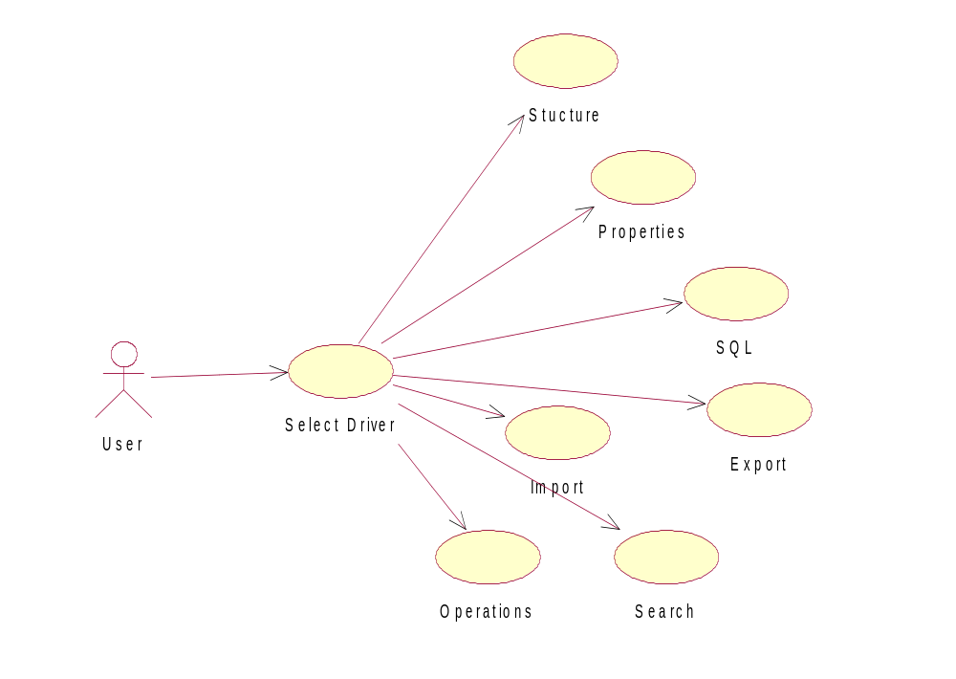

Sequential-diagram

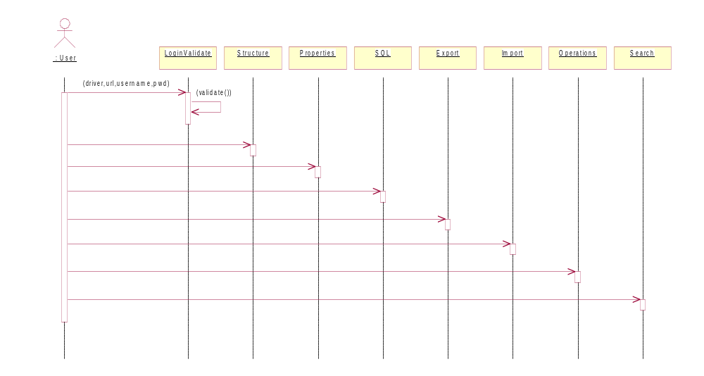

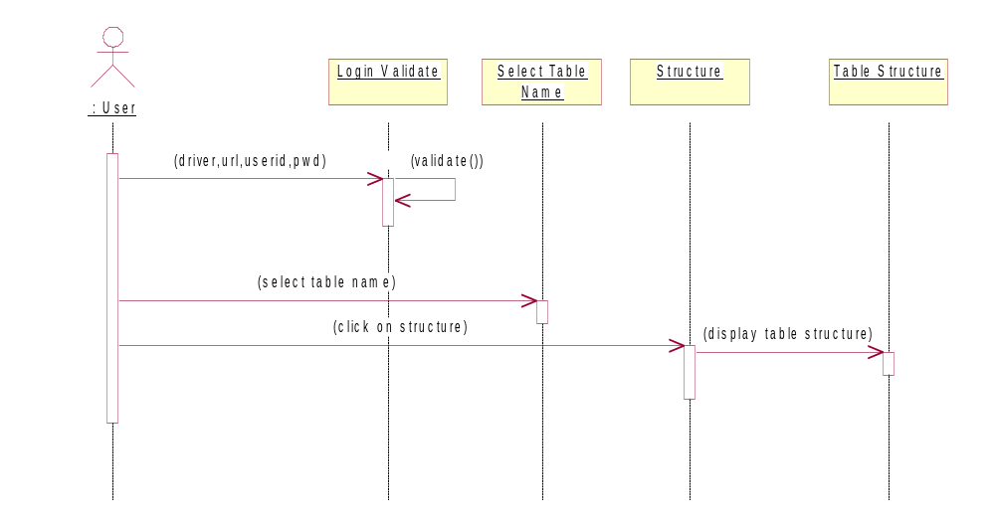

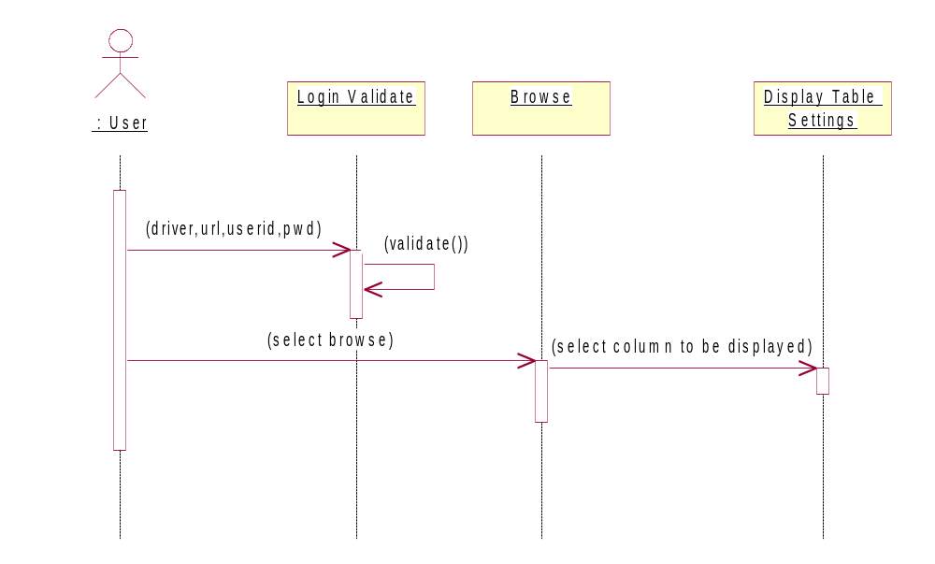

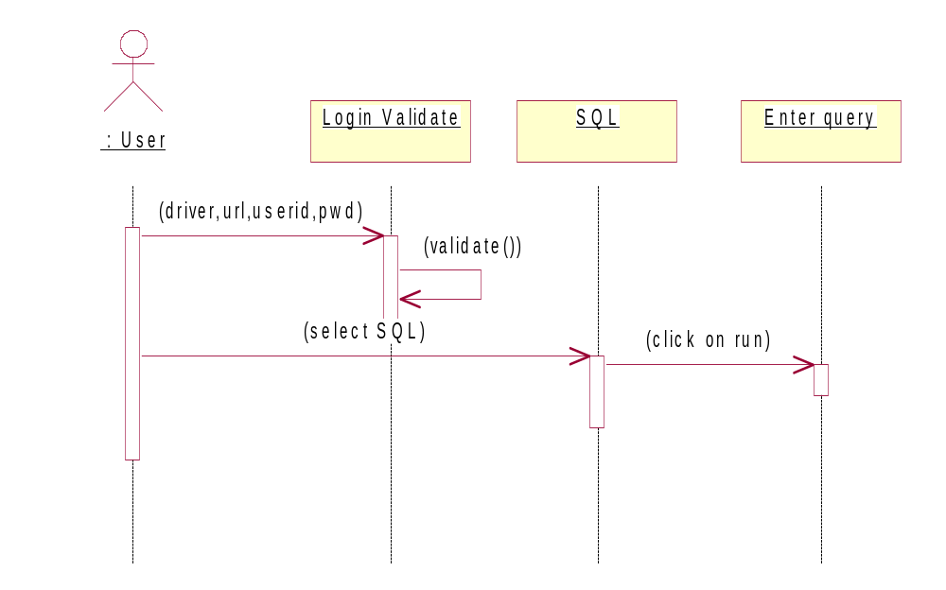

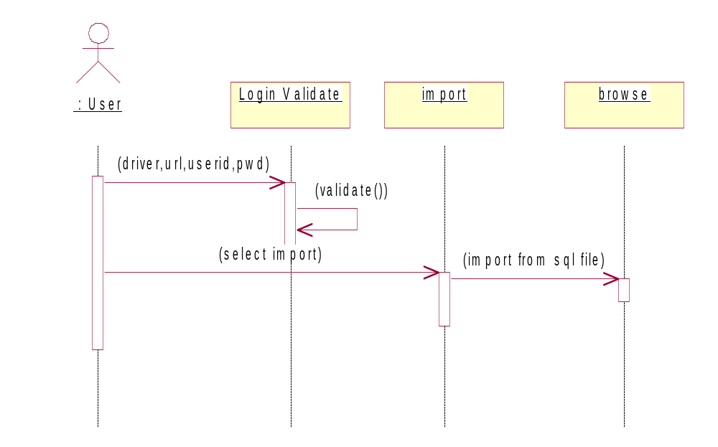
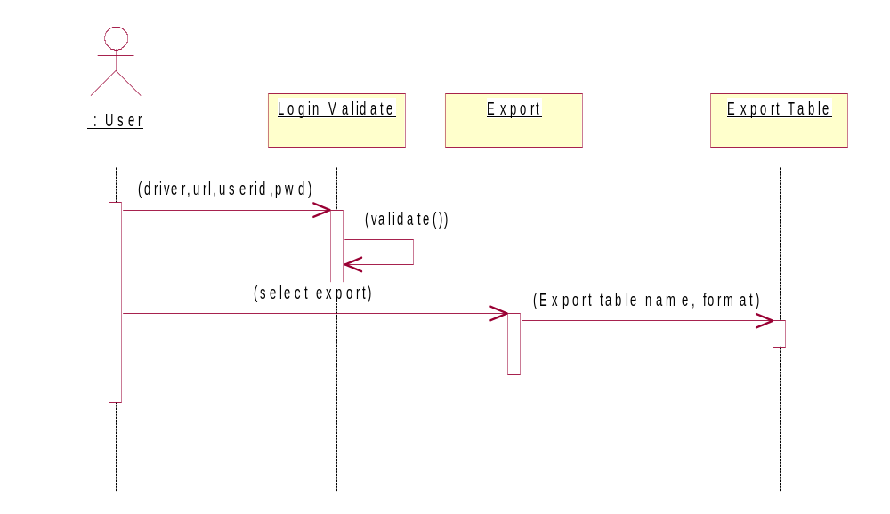

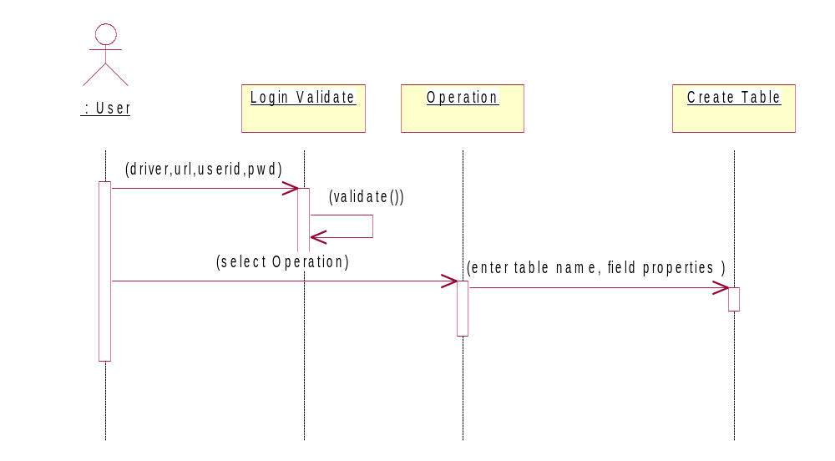

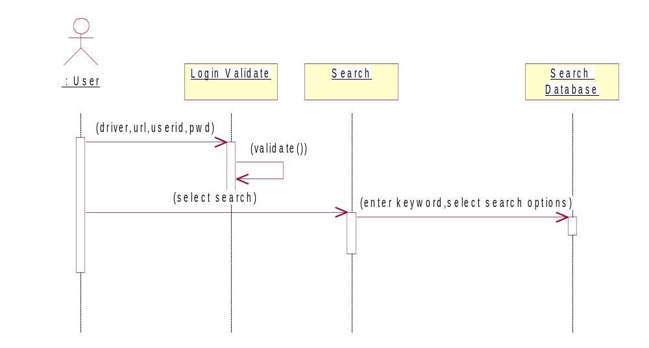

Class –diagram
DataManipulator
Edit Form
Create Tab
Renametab
InputScreen
Report
Menu
GUIComponent
Empty column
DataStore
Desc tab

Browse Form

List DB

<<instantiates>>
<<uses>>
Options
DBOperations

State-diagram

unauthenticated
validation
authenticated
( id,pwd )
( ok )
( id,pwd )

unauthenticated
Validation
DB Menu
( Driver,username,pwd)
( invalid )
( valid )

Context level Diagram

Data Base Interface

MY-SQL
MS-SQL Server

ORACLE
MS-Access
Driver
URL
Login ID
Password
Level 1 DFD

Driver
URL
Login ID
Password

Diver?

Oracle Driver
MY-SQL Driver

DATA
DATA
ID & Pass word
ID & Pass word

MY-SQL

ORACLE

DFD for STRUCTURE Module
Driver
URL
Login ID
Password

JDBC

DB
ID & Pass word
List of Tables
TABLE NAME

Display the Structure

DFD for PROPERTIES Module
Driver
URL
Login ID
Password

JDBC

DB
ID & Pass word
List of Tables
TABLE NAME

Display the Records
No. Of Records per page
Fields to be displayed
DFD for SQL Module
Driver
URL
Login ID
Password

JDBC

DB
ID & Pass word
List of Tables
SQL Query

Display the Results
DFD for IMPORT Module

Driver
URL
Login ID
Password

JDBC

DB
ID & Pass word
List of Tables
Select the Source Data Base
Select the Source Table
Source
DB
DFD for EXPORT Module

Driver
URL
Login ID
Password

JDBC

DB
ID & Pass word
List of Tables
Select the Table
Select the Export Format
Exported Table details
DFD for Creation of Table

Driver
URL
Login ID
Password

DBI

DB
ID & Pass word
List of Tables
Choose Create Table
Specify the Fields & sizes
Table Created
DFD for Search Module
Driver
URL
Login ID
Password

DBI

DB
ID & Pass word
List of Tables
Search data
Specify the tables
Results
Result for Structure
- Emp Table
Name Datatype size
empno Number 4
empname Varchar2 10
job Varchar2 9
mgr Number 4
Hiredate Date
salary Number 7,2
comm Number 7,2
deptno Number 2

- Dept Table
Name Datatype size
deptno Number 2
dname Varchar2 14
loc Varchar2 13

Result of Properties
- Dept Table
DEPTNO DNAME LOC
10 ACCOUNTING NEW YORK
20 RESEARCH DALLAS
30 SALES CHICAGO
40 OPERATIONS BOSTON

Result of SQL module
- Select empno, ename, sal from emp where sal<2000
EMPNO ENAME SAL
7369 SMITH 800
7499 ALLEN 1600
7521 WARD 1250
7654 MARTIN 1250
7844 TURNER 1500
7876 ADAMS 1100
7900 JAMES 950
7934 MILLER 1300

